1. I think Mathews’ ranking method is indeed misleading and inappropriate, but the reasons behind it are somewhat interesting to me. The article analyzes the reasons from three perspectives in a logical way. One of the most straightforward drawbacks is that it only uses one factor, and the ranking of schools is not unary.

Also, I want to know if an alternative index works much better than the Mathews index. I hold the idea that it is necessary to rank high schools. I am currently studying in the best international high school in the central China region, and I appreciate it a lot since the faculty resources and peer environment suits me. Almost all people pursue higher rankings, and the desire to enter high-leveled schools can stimulate students to work harder to get better grades.

2. (a)

(b)

[[‘alpha’, 0.2789]

[‘beta’, 0.2625]

[‘delta’, 0.1908]

[‘gamma’, 0.1338]

[‘sigma’, 0.1056]

[‘rho’, 0.0284]]

3.

Root page: https://en.wikipedia.org/wiki/Main_Page

Top 10:

Rank PageRank Webpage

==============================================

0 0.25008 /wiki/Main_Page

1 0.10450 /wiki/ISBN_(identifier)

2 0.01568 /wiki/Vietnam_War

3 0.01417 /wiki/Royal_Navy

4 0.01289 /wiki/General_Motors

5 0.01238 /wiki/California

6 0.01236 /wiki/LaSalle_(automobile)

7 0.01236 /wiki/Pontiac_(automobile)

8 0.01236 /wiki/Cadillac

9 0.01236 /wiki/Oldsmobile

4. The application is the food chain relationship between brawlers in Brawl Stars, one of my most favorite videos games. 5 brawlers, El Primo (tank), Barley (thrower), Shelly (fighter), colt (sharpshooter), and Mortis (assassin) have a sort of predator and prey relationship.

The adjacency matrix is:

$$\left(\begin{matrix} & El Primo & Barley & Shelly & Colt & Mortis \\ El Primo & 0 & 0 & 0 & 0 & 1 \\ Barley & 1 & 0 & 1 & 0 & 0 \\ Shelly & 1 & 0 & 0 & 0 & 1 \\ Colt & 1 & 1 & 1 & 0 & 0 \\ Mortis & 0 & 1 & 0 & 1 & 0\end{matrix}\right)$$

Spy plot:

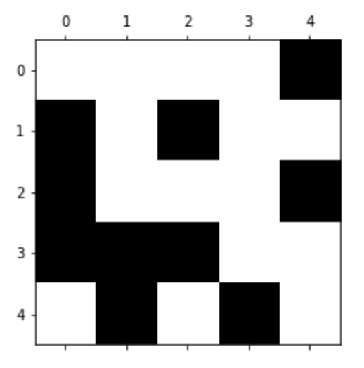

The graph look like this:

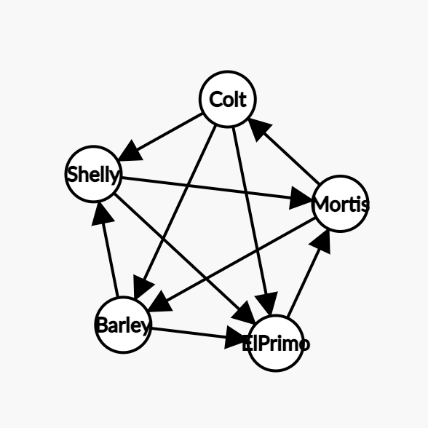

Each node represents a brawler, and the arrow from A to B means A counters B.

The PageRank for this network is:

[[‘El Primo’, 0.2209]

[‘Barley’, 0.1938]

[‘Shelly’, 0.1546]

[‘Colt’, 0.1483]

[‘Mortis’, 0.2824]]

5. I think PageRank is applicable for my idea of ranking economies around the world. The nodes represent countries, and arrows represent relationships between countries, such as cooperation or economics sanctions. The arrows, or directed edges, could be weighted to represent import and export data. But this model seems a lot complicated than the PageRank algorithm we are currently studying. I’m finding ways to simplify my application.

My research question will still be investigating rankings and relationships between countries and their economic development, but the detail still requires time to be settled down.